## 矩阵相等

如果两个矩阵的维数相同，所有成员也相同，那么就说这两个矩阵相等。只要有一个条件不满足，这两个矩阵就不等。

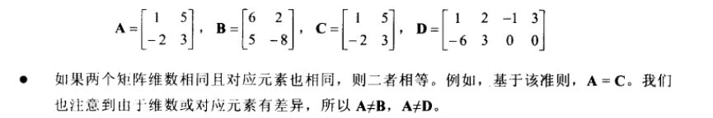

## 标量乘于矩阵

**就是用标量乘于矩阵的每一个元素。**

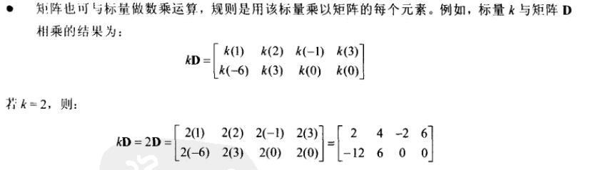

## 矩阵的加减

**两个矩阵只有维数相同的时候才能进行相加。两个矩阵的和就是两个矩阵对应元素分别相加得到的矩阵。**

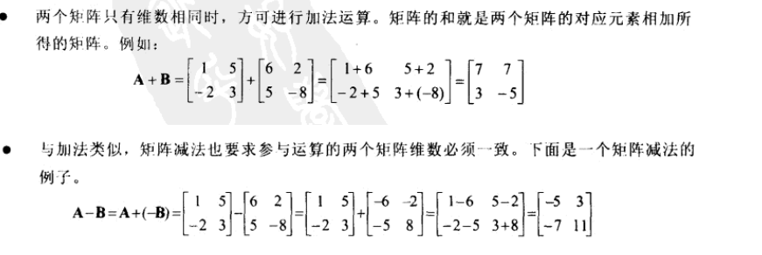

## 矩阵的乘法

**必须满足如下条件：矩阵A乘于矩阵B，则A的行数必须等于矩阵B的列数，而且AB!=BA**

**具体运算方法**

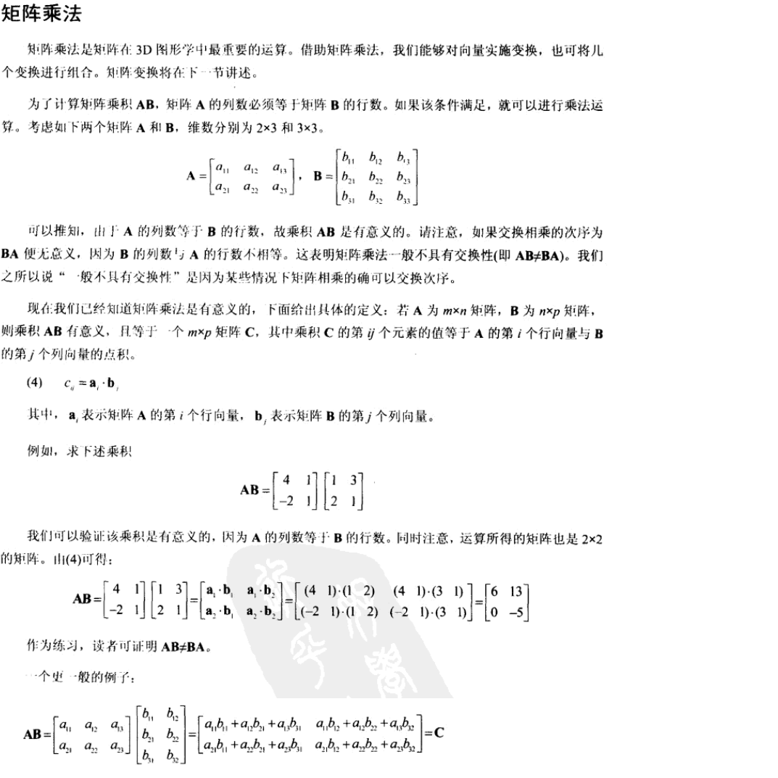

## 5.单位矩阵

就是只有主对角线的元素的值是1，其余的元素都是0的矩阵（Identity Matrix）

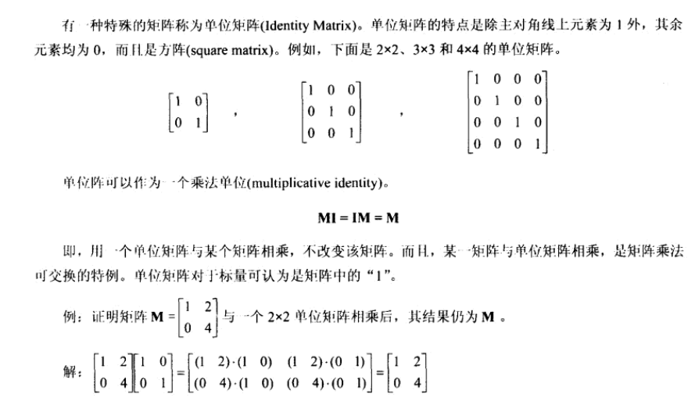

## 6矩阵的逆

**注意：只有方阵（行数和列数相等的矩阵）才于逆矩阵**

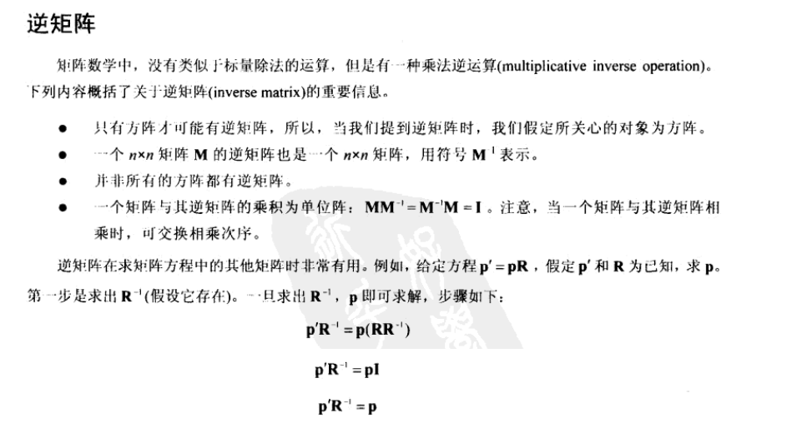

## 7．矩阵的转置

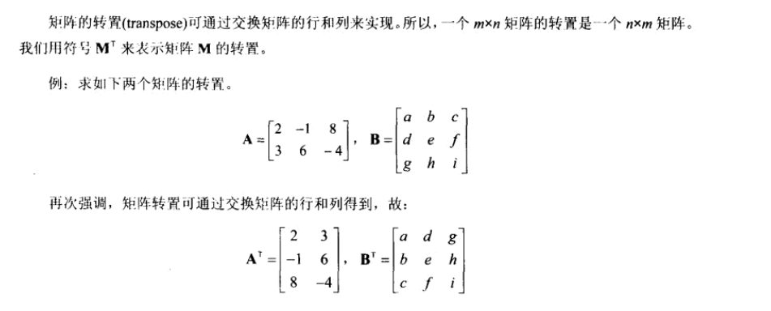

## 8.D3DX矩阵

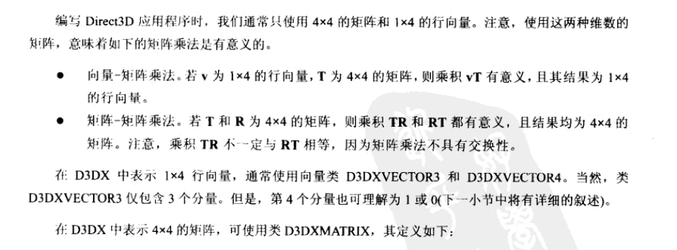

D3DX库中，1x4向量使用D3DXVECTOR3和D3DXVECTOR4。D3DXVECTOR3只包含三个分量，但是可以理解为它的第四个分量是1或0 .

4X4矩阵可以使用D3DXMATRIX:

|  |
| --- |
| typedef struct D3DXMATRIX : public D3DMATRIX  {  public:  D3DXMATRIX() {};  D3DXMATRIX( CONST FLOAT * );  D3DXMATRIX( CONST D3DMATRIX& );  D3DXMATRIX( CONST D3DXFLOAT16 * );  D3DXMATRIX( FLOAT _11, FLOAT _12, FLOAT _13, FLOAT _14,  FLOAT _21, FLOAT _22, FLOAT _23, FLOAT _24,  FLOAT _31, FLOAT _32, FLOAT _33, FLOAT _34,  FLOAT _41, FLOAT _42, FLOAT _43, FLOAT _44 );  // access grants  FLOAT& operator () ( UINT Row, UINT Col );  FLOAT operator () ( UINT Row, UINT Col ) const;  // casting operators  operator FLOAT* ();  operator CONST FLOAT* () const;  // assignment operators  D3DXMATRIX& operator *= ( CONST D3DXMATRIX& );  D3DXMATRIX& operator += ( CONST D3DXMATRIX& );  D3DXMATRIX& operator -= ( CONST D3DXMATRIX& );  D3DXMATRIX& operator *= ( FLOAT );  D3DXMATRIX& operator /= ( FLOAT );  // unary operators  D3DXMATRIX operator + () const;  D3DXMATRIX operator - () const;  // binary operators  D3DXMATRIX operator * ( CONST D3DXMATRIX& ) const;  D3DXMATRIX operator + ( CONST D3DXMATRIX& ) const;  D3DXMATRIX operator - ( CONST D3DXMATRIX& ) const;  D3DXMATRIX operator * ( FLOAT ) const;  D3DXMATRIX operator / ( FLOAT ) const;  friend D3DXMATRIX operator * ( FLOAT, CONST D3DXMATRIX& );  BOOL operator == ( CONST D3DXMATRIX& ) const;  BOOL operator != ( CONST D3DXMATRIX& ) const;  } D3DXMATRIX, *LPD3DXMATRIX; |

D3DMATRIX等于如下：

|  |
| --- |
| typedef struct _D3DMATRIX {  union {  struct {  float _11, _12, _13, _14;  float _21, _22, _23, _24;  float _31, _32, _33, _34;  float _41, _42, _43, _44;  };  float m[4][4];  };  } D3DMATRIX; |

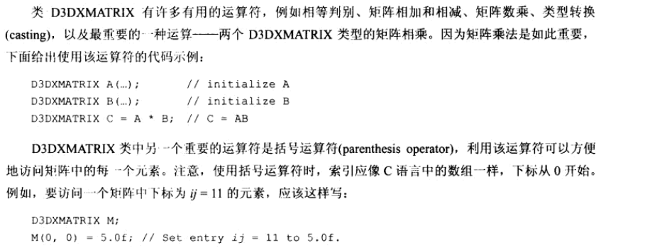

D3DXMATRIX常用函数

1. 转换为单位矩阵

|  |
| --- |
| D3DXINLINE D3DXMATRIX* D3DXMatrixIdentity ( D3DXMATRIX /*需要转换的矩阵*/*pOut ) |

1. 矩阵转置

|  |
| --- |
| D3DXMATRIX* WINAPI D3DXMatrixTranspose( D3DXMATRIX /*接收结果的矩阵*/*pOut, CONST D3DXMATRIX /*需要转置的矩阵*/*pM ); |

1. 求矩阵的行列式，只有方阵才有行列式

|  |
| --- |
| FLOAT WINAPI D3DXMatrixDeterminant( CONST D3DXMATRIX *pM ); |

4）矩阵的逆矩阵

|  |
| --- |
| D3DXMATRIX* WINAPI D3DXMatrixInverse ( D3DXMATRIX *pOut, FLOAT *pDeterminant, CONST D3DXMATRIX *pM );  // pOut接收返回值，pDeterminant：determinant，行列式可以为0，pM需要转置的矩阵指针 |

矩阵的行列式计算方法：

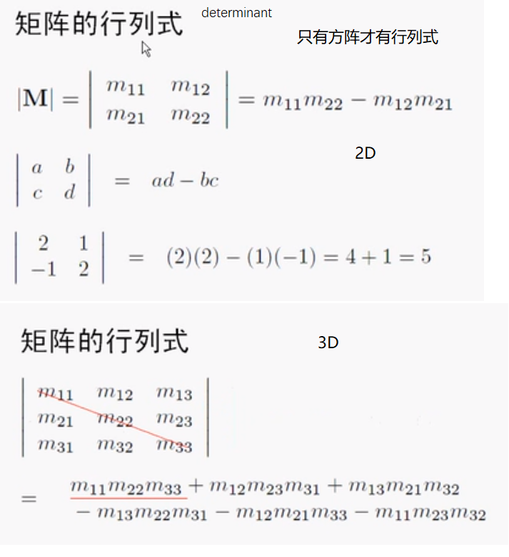

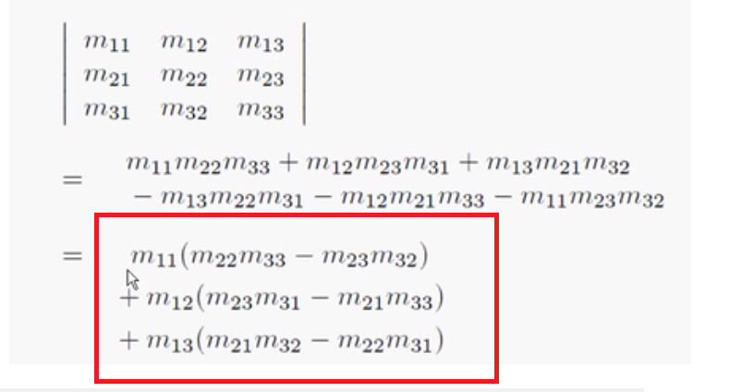

## 9.矩阵的基本变换

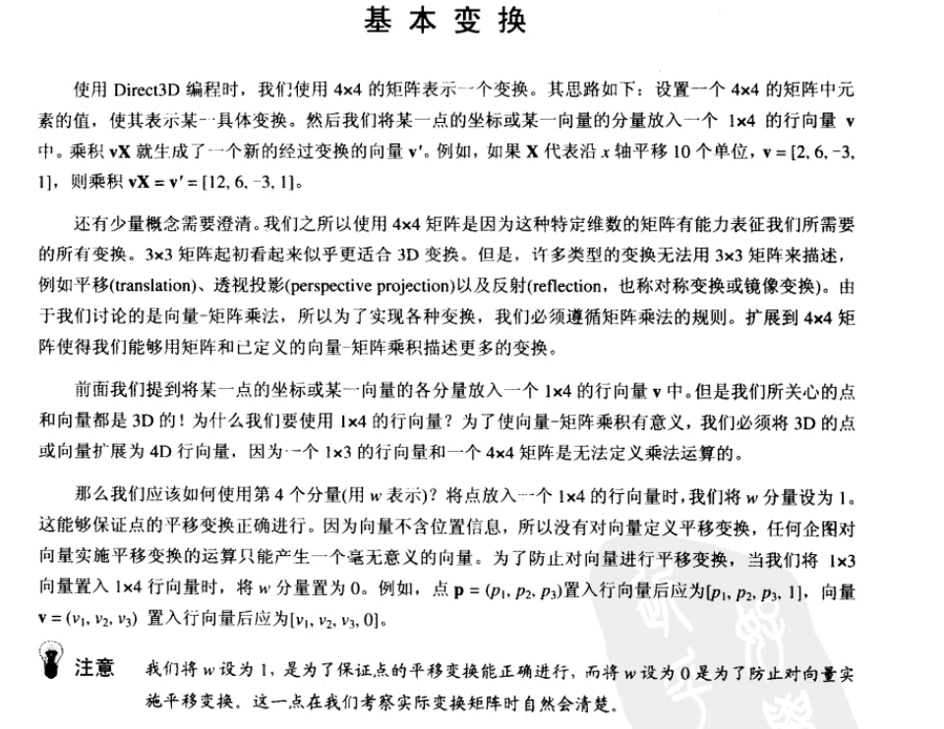

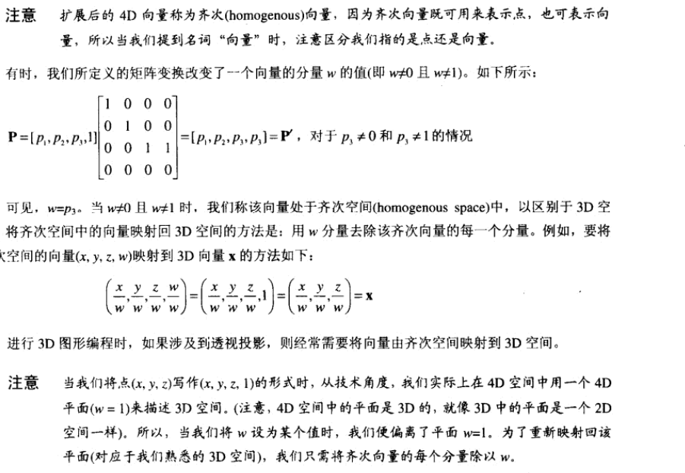

## 10平移矩阵

如图：

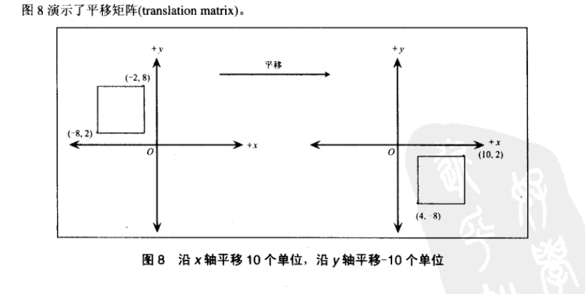

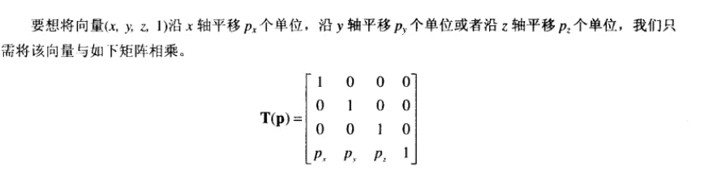  
最后一行是用于平移的，由于平移后的矩阵后原来的矩阵值的一样的所有疑似矩阵处理平移那一行，其余的是单位矩阵



|  |
| --- |
| **// Build a matrix which translates by (x, y, z)**  **D3DXMATRIX* WINAPI D3DXMatrixTranslation( D3DXMATRIX *pOut, FLOAT x, FLOAT y, FLOAT z );**  **//pOut用来保存结果，x,y,z是平移坐标** |

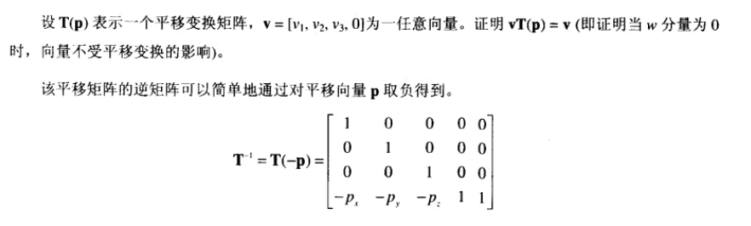

## 11.旋转矩阵

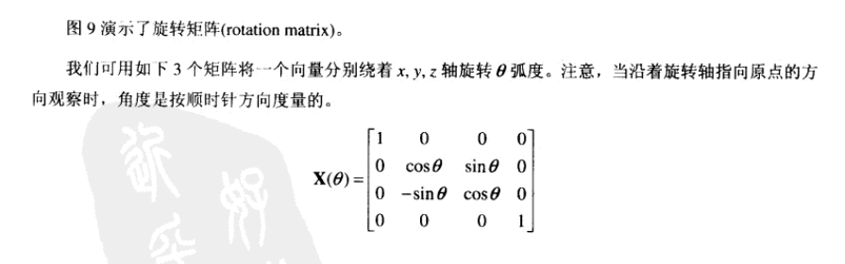

创建绕x轴旋转的D3DX函数：

|  |
| --- |
| **// Build a matrix which rotates around the X axis**  **D3DXMATRIX* WINAPI D3DXMatrixRotationX( D3DXMATRIX *pOut, FLOAT Angle );**  **//pOut保存结果，Angle是旋转角度** |

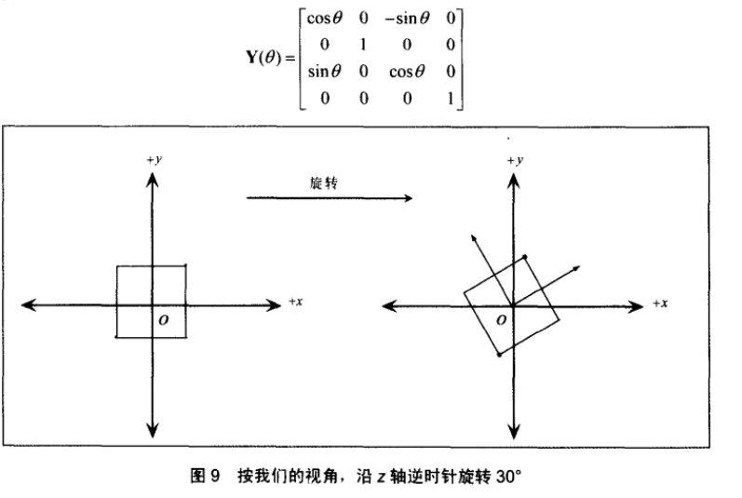

创建绕y轴旋转的D3DX函数：

|  |
| --- |
| **// Build a matrix which rotates around the Y axis**  **D3DXMATRIX* WINAPI D3DXMatrixRotationY( D3DXMATRIX *pOut, FLOAT Angle );**  //pOut保存结果，Angle是旋转角度 |

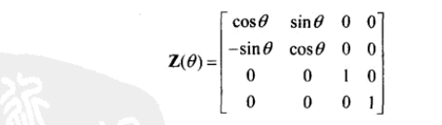

创建绕Z轴旋转的D3DX函数：

|  |
| --- |
| // Build a matrix which rotates around the Z axis  **D3DXMATRIX* WINAPI D3DXMatrixRotationZ( D3DXMATRIX *pOut, FLOAT Angle );**  //pOut保存结果，Angle是旋转角度 |

## 12.比例变换矩阵

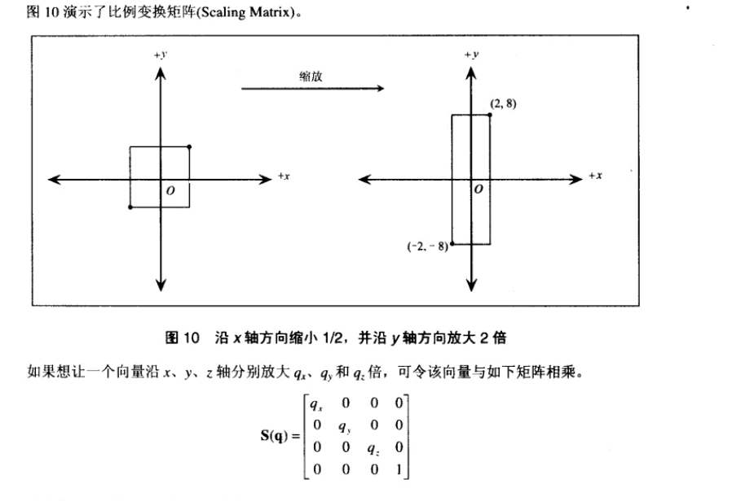

D3DX库创建比例矩阵的函数

|  |
| --- |
| D3DXMATRIX* D3DXMatrixScaling(  _Inout_ D3DXMATRIX *pOut,  _In_    FLOAT      sx,  _In_    FLOAT      sy,  _In_    FLOAT      sz  ); |



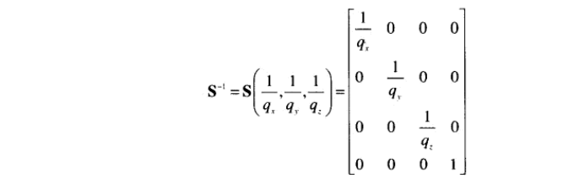

## 13.几何变换组合

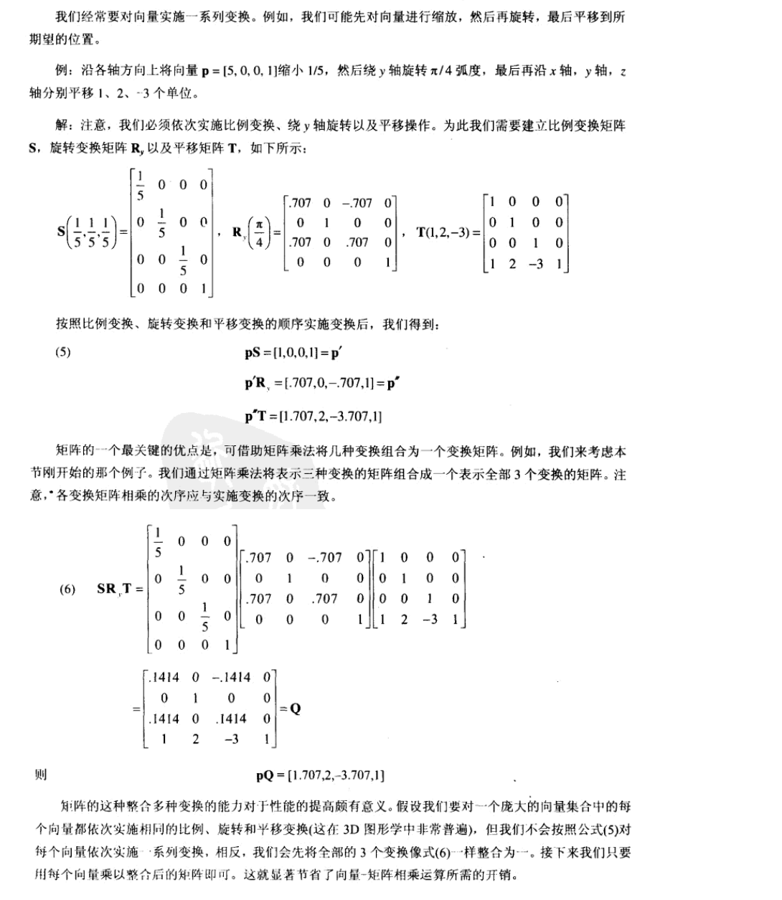

D3DX向量变换函数对点进行变换

|  |
| --- |
| D3DXVECTOR3* WINAPI D3DXVec3TransformCoord( D3DXVECTOR3 *pOut, CONST D3DXVECTOR3 *pV, CONST D3DXMATRIX *pM ); |

D3DX向量变换函数对点数组进行变换

|  |
| --- |
| D3DXVECTOR3* WINAPI D3DXVec3TransformCoordArray  ( D3DXVECTOR3 *pOut, UINT OutStride, CONST D3DXVECTOR3 *pV, UINT VStride, CONST D3DXMATRIX *pM, UINT n ); |

D3DX向量变换函数对向量进行变换

|  |
| --- |
| D3DXVECTOR3* WINAPI D3DXVec3TransformNormal( D3DXVECTOR3 *pOut, CONST D3DXVECTOR3 *pV, CONST D3DXMATRIX *pM ); |

D3DX向量变换函数对向量数组进行变换

|  |
| --- |
| D3DXVECTOR3* WINAPI D3DXVec3TransformNormalArray  ( D3DXVECTOR3 *pOut, UINT OutStride, CONST D3DXVECTOR3 *pV, UINT VStride, CONST D3DXMATRIX *pM, UINT n ); |